
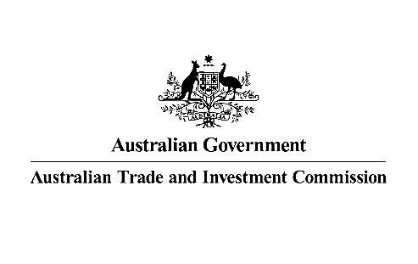

SENIOR Business development manager-GREEN ECONOMY

The Australian Government has a focus on supporting Australian businesses to diversify exports and grow in new markets. As part of this role, you will work closely with peak industry bodies to deliver a program of activities that support the diversification of Australian exporters into new markets and helps exporters to grow in established markets. You will be based in the Austrade office in Kuala Lumpur, Malaysia and will be reporting to the Trade and Investment Commissioner.
This position requires experience in influencing major business decisions especially in the green economy and deep knowledge of Malaysia’s green economy sector, key organisations and the motivations of businesses internationally. You should be highly fluent in the language of business, with the ability to recognise trade opportunities and help business progress by creating meaningful links and connections.
You must have excellent interpersonal and written and oral communication skills and experience (including negotiation, influencing and representation at high levels of government and business leaders). You should be able to support the delivery of in-market trade events and business missions in addition to delivering targeted and high impact support to Australian businesses. This includes being able to leverage local market expertise to raise awareness of new export opportunities amongst target Australian businesses.
You must be confident in the use of in the use of digital workplace tools to solve problems, be productive, connect and collaborate with others. Being able to achieve work goals with minimum supervision, with strong project and time management skills will be advantageous. Someone who enjoys working in a multi-disciplinary and diverse team environment. You must have strong commitment to professional transparency and integrity with the ability to adhere to the standards and values of Austrade and the Australian Public Service

As Senior Business Development Manager, you will be responsible to :
- Grow Australia’s exports to the market by providing trade advice to a portfolio of targeted Australian businesses from the green economy sectors.
- Identify opportunities for Australian businesses by leveraging local market expertise and undertaking sector research.
- Establish and maintain close working relationships with targeted peak industry bodies, in collaboration with Austrade’s Australia based team.
- Plan and support visits to the market by Australian peak industry bodies and Australian businesses, helping to design visit programs that deliver trade outcomes and foster new business linkages.
- Work collaboratively within the Austrade network to contribute to service delivery and achieve desired outcomes, including by maintaining a strong connection with Austrade’s Australia-based staff.
- Uphold a best practice approach to client servicing, and embrace Austrade’s digital approach to client service delivery.
- Ensure a strong working relationship with other Australian agencies in the market including the Department of Foreign Affairs and Trade and state and territory government agencies
This is a locally-engaged position governed by Malaysian Labour Law and Austrade’s Overseas Engaged Employees Terms and Conditions of Employment. Candidates must be eligible to live and legally work in Malaysia at the time of appointment.
For further details and to apply, please head to our website for the Information Pack and complete the online application form at Austrade - Senior Business Development Manager-Green Economy
Only candidates who complete their application in Austrade’s online recruitment system will be considered.
Applications Close: Sunday 24 August 2025 at 11:30pm (Malaysia time)

