18 MAY 2019
[FOR IMMEDIATE RELEASE]

AUSTRALIAN DEMOCRACY IN ACTION - FEDERAL ELECTION DAY EVENT

On Saturday 18 May, the day of the Australian Federal Election, the Australian High Commission opened its doors for a special briefing to a delegation from the Malaysian Government, public servants and members of the media. This was an opportunity for participants to learn more about the role of Australia’s diplomatic network in supporting overseas voting for Australians.

The Australian High Commission Kuala Lumpur is one of around 90 overseas voting centres for the Australian Federal Election, providing in-person voting services. Overseas voting allows Australians travelling or living overseas the ability to participate in the democratic process and have their vote count.

The Assistant Returning Officer, and Australian High Commission Consul charged with overseeing the voting process in Malaysia, provided the briefing. Topics included the cooperation between the Australian Electoral Commission and the High Commission, the process of conducting elections overseas, rules for access and set-up, and the process for voting.

Guests at the briefing included Tan Sri Rashid Abdul Rahman, Chairman of the Electoral Reform Committee, YB Hannah Yeoh, Deputy Minister of Women, Family and Community Development, YB Liew Chin Tong, Deputy Minister of Defence, YBhg Datuk Roosme Hamzah, Secretary of the Dewan Rakayt, representatives from UNDP Malaysia, and staff of the Election Commission.

The Australian High Commissioner to Malaysia, HE Andrew Goledzinowski, also announced that Australia would contribute an additional $400,000 AUD (approx. RM 1.2 million) to the UNDP Electoral Reform Assistance Project in Malaysia, taking Australia’s total contribution to $1 million AUD (RM 3 million).The UNDP is working with the Election Commission and Electoral Reform Committee as they progress reform of the Malaysian electoral system.

It is estimated that around 1,000 Australians cast their ballots in at the High Commission over the two week voting period (advanced voting and on polling day). High Commissioner Goledzinowski also cast his vote during the briefing event.

Upholding an Australian election tradition, the High Commission held a ‘Democracy Sausage’ sizzle during which the High Commissioner wielded the tongs. This election fixture has earned its own Twitter emoji @DemSausage. Proceeds from the sausage sizzle were donated to Women’s Aid Organisation, a Malaysian NGO that provides free shelter, counselling, and crisis support to women and children who experience abuse. The High Commission’s BBQ was included on the global Democracy Sausage map. By the end of 2016, 'democracy sausage' was cemented into the Australian vernacular when it was crowned Word of the Year.

High Commissioner Goledzinowski said today’s event was a celebration of Australia's democratic system. “Australian elections, regardless of who you support, are always conducted in a spirit of warmth and friendliness at the voting centers, and today’s event is an expression of that".

Voting in Australia is compulsory for Australian citizens aged over 18 years. 96.8 per cent of eligible Australians enrolled to vote this year - this represented 750,000 more Australians than for the 2016 Federal Election. Around 80,000 people are expected to vote at Overseas Voting Centers during the 2019 Australian Federal Election. The Australian Electoral Commission distributed an impressive 5.5 tonnes of election material internationally.

For more facts and figures on Australia’s 2019 Federal Election, please visit www.aec.gov.au.

/End

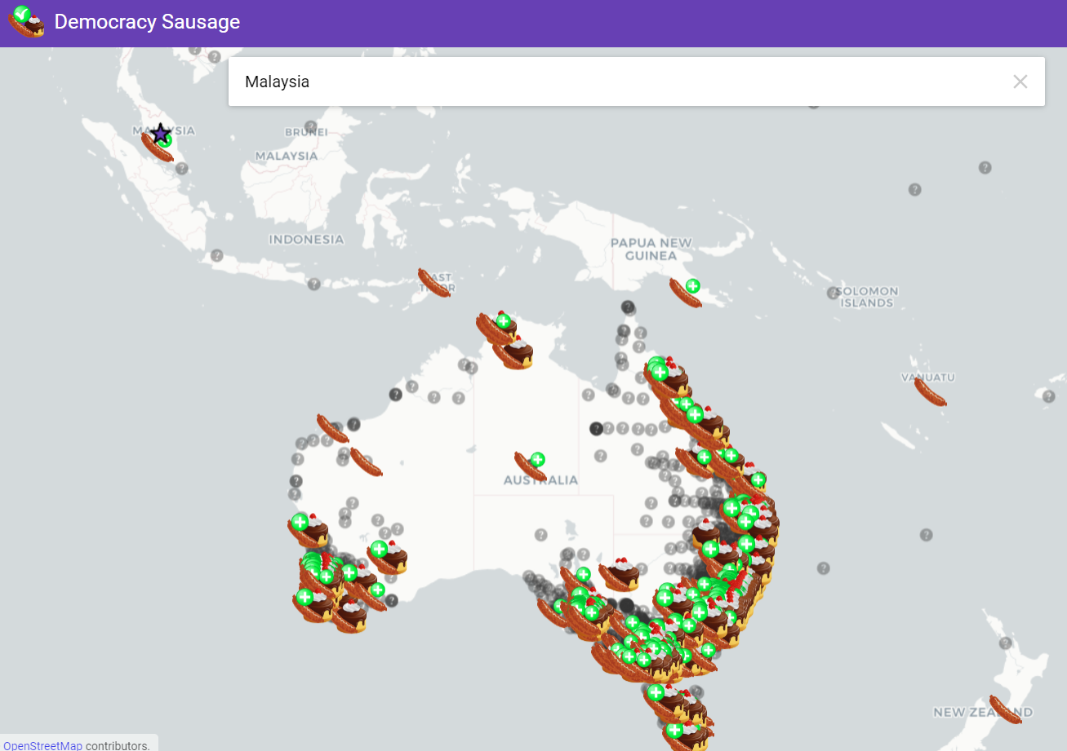
Source: https://democracysausage.org/federal_election_2019

